Selecting for Functional Alternative Splices in ESTs
Zhengyan Kan, David states, and Warren Gish
Genome Research ,Vol. 12, Issue 12, 1837-1845, December 2002
Abstract
The expressed sequence tag (EST) collection in dbEST provides an extensive resource for detecting alternative splicing on a genomic scale. Using genomically aligned ESTs, a computational tool (TAP) was used to identify alternative splice patterns for 6400 known human genes from the RefSeq database. With sufficient EST coverage, one or more alternatively spliced forms could be detected for nearly all genes examined. To identify high (>95%) confidence observations of alternative splicing, splice variants were clustered on the basis of having mutually exclusive structures, and sample statistics were then applied. Through this selection, alternative splices expected at a frequency of >5% within their respective clusters were seen for only 17%-28% of genes. Although intron retention events (potentially unspliced messages) had been seen for 36% of the genes overall, the same statistical selection yielded reliable cases of intron retention for <5% of genes. For high-confidence alternative splices in the human ESTs, we also noted significantly higher rates both of cross-species conservation in mouse ESTs and of validation in the GenBank mRNA collection. We suggest quantitative analytical approaches such as these can aid in selecting useful targets for further experimental characterization and in so doing may help elucidate the mechanisms and biological implications of alternative splicing.
- Results
Fig 1. Overview of alignment procedures
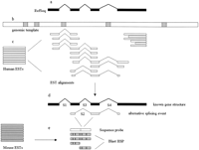

Fig 2. Mutually exclusive patterns
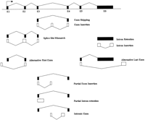

Fig 4. Prevalence Fig 5. Greater observerd frequency
of alternative splicing is associated with functional indicators
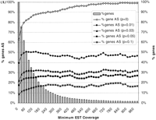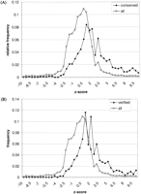

- Methods

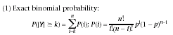
Created by: Huei-Ming Yang
Date: Mar. 12,2004

